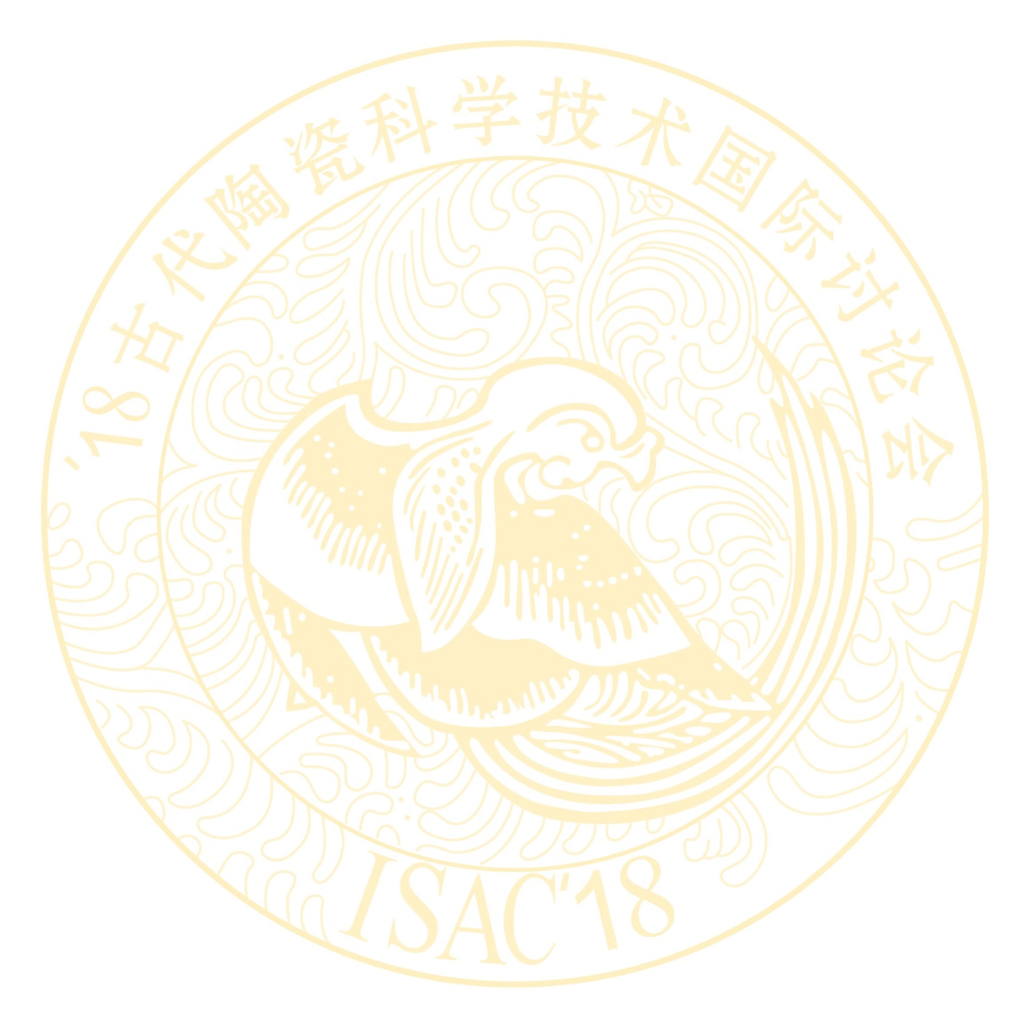
Notice No. 2 of

2018 INTERNATIONAL SYMPOSIUM ON ANCIENT CERAMICS
-Its Scientific and Technological Insights
(ISAC 2018)

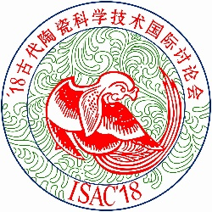

November 6 ~ 9, 2018
Hope Hotel, Shanghai, China

Sponsored by:
Shanghai Institute of Ceramics, Chinese Academy of Sciences
Organized by:
Shanghai Research Society of Science and Technology of Ancient Ceramics (SRSSTAC)

Introduction to the Symposium
The 2018 International Symposium on Ancient Ceramics (ISAC-2018) will take place in Shanghai, China on November 6-9, 2018. The International Symposium on Ancient Ceramics (ISAC) has been proved to be a high-level academic symposium and an important platform for academic exchange amongst ancient ceramic experts at home and abroad. Since the first symposium in 1982, ISAC has won high praises from academic researchers and experts from all over the world.

Symposium Topics:
- Science and technology of ancient ceramics
- Archaeology of ceramics
- Trading of ancient ceramics
- Techniques and artistry of ancient ceramics
- Analytical methods
- Kiln and imitation
- Preservation and Restoration

Language used in the Symposium:
- English (15minutes for speech and 5 minutes for Q&A).

Schedule:
Please check in at HOPE Hotel on November 6, 2018. The Symposium will begin on November 7 and conclude on November 9.

Symposium Registration Fee:
Including proceedings, meals, coffee break, stationery etc. Paying Registration fee for:
Participant:
Before July 31, 2018: ¥3000(RMB)/person;
After July 31, 2018: ¥3200 (RMB)/person,
Accompanying guest (excluding proceedings):
Before July 31, 2018: ¥2000(RMB)/person;
After July 31, 2018: ¥2200(RMB)/person,
Student:
Before July 31, 2018: ¥2000(RMB)/person;
After July 31, 2018: ¥2200(RMB)/person.

Hotel Accommodation:
All participants are kindly requested to cover their own accommodation cost at HOPE hotel. Please refer to the following room types and rates.

- HOPE Hotel:
Suite room：about ¥800(RMB)/room per day
Single room：about ¥600(RMB)/room per day
Double room：about ¥620(RMB)/room per day

Address: No. 500, Zhaojiabang Road, Xuhui District, Shanghai.
Tel: 0086-21-64716060
http://www.hope-hotel.com

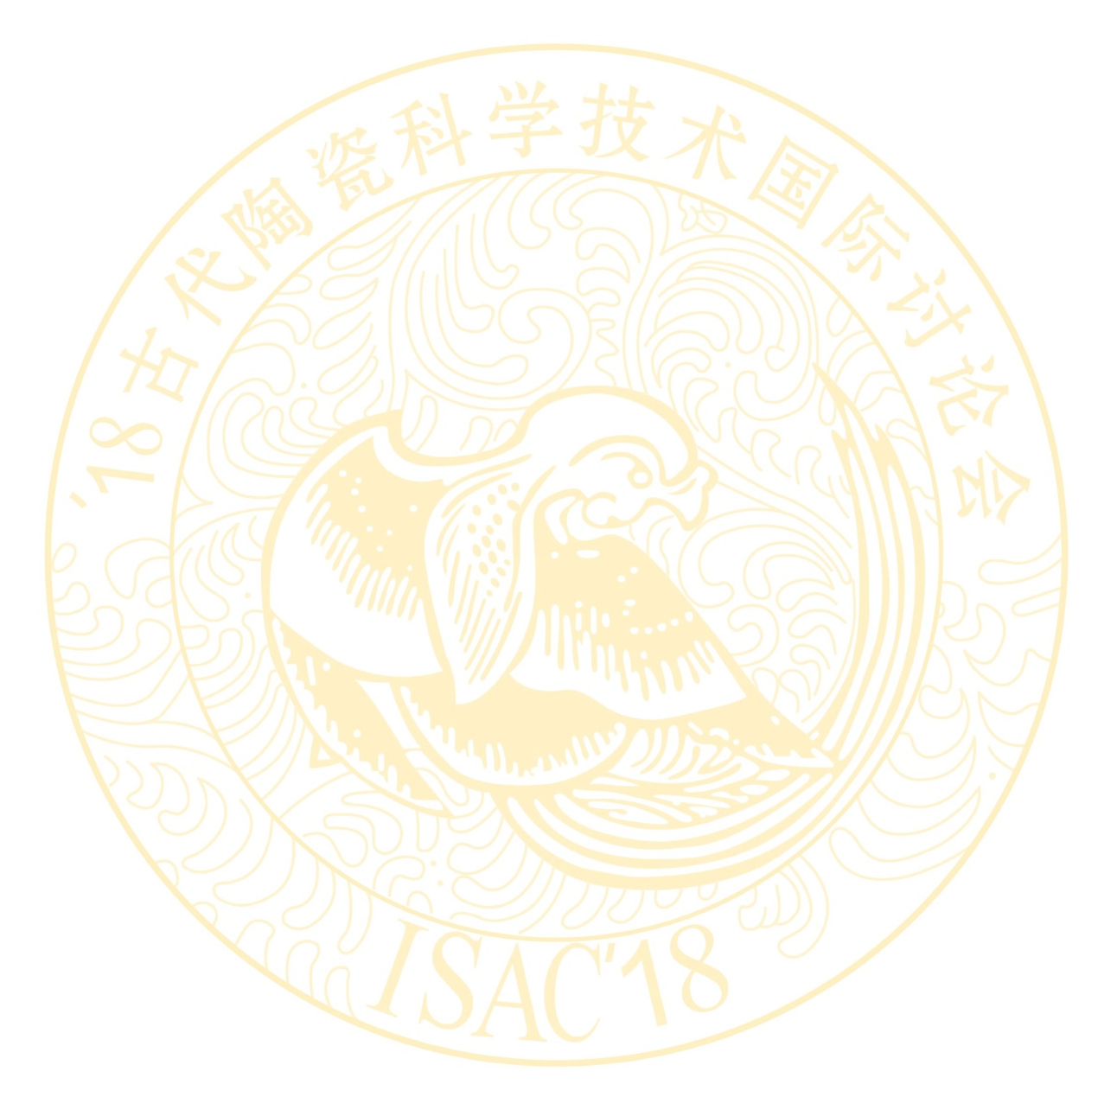
Method of Payment

Please remit the registration fee and/or the Field Trip fee to the following bank account and address, and indicate the purpose of payment (ISAC’18/trip, Your name, Comany). Personal check will not be accepted.

A/C No.: 1001223609014446346
Beneficiary Name:
Shanghai Research Society of Science and Technology of Ancient Ceramics
Swift CODE: ICBKCNBJSHI
Bank Name: Industrial and Commercial Bank of China Shanghai Municipal Branch Changning Sub-Branch
BANK ADDRESS: No.895 West Yan’an Road Shanghai China
Beneficiary Address: 1295 Dingxi Road, Shanghai 200050, P.R. China

Passport and Visa upon receiving your Registration Form and a copy of your Remittance Receipt, we will send out a letter of invitation for your visa application. Citizens of all other nations are required to obtain visas from the Chinese Embassy or Consulate General of the People’s Republic of China. Please inform us on the Embassy or Consulate General that you will obtain your visa from by filling in the Registration Form attached below, so that we can send a complete list of names to the proper diplomatic establishment.

Contact Person:
Ms. Xu Changsong, xuchangsong@student.sic.ac.cn
Mr. Lu Xiaoke, luxiaoke@mail.sic.ac.cn
Ms. Gu Zhonghua, guhua@mail.sic.ac.cn

Shanghai Institute of Ceramics,
Chinese Academy of Sciences,
1295 Dingxi Road, Shanghai 200050

Tel.: +86 21 52411107 or 52411108
Fax: +86 21 52411107

2018 INTERNATIONAL SYMPOSIUM ON ANCIENT CERAMICS
----Its Scientific and Technological Insights

ISAC ’18

November 6-9, 2018, Shanghai, China

REGISTRATION FORM
Please complete and return this form with a copy of your remittance receipt to Ms. Xu Changsong, Secretariat of ISAC’18, no later than July 31, 2018. Your information in this form is also required for visa application.

Full Name of Participant/ Accompanying Guest:
(Dr./Prof./Mr./Mrs./Miss) ,
(Surname) (First name)
Sex: Male/Female
Date of Birth: Nationality:

Present Occupation and Position:

Organization:

Mailing Address:

City: State:

Zip: Country:

Phone: Telex:

Fax: E-Mail:

Passport No.: Date and place of issue:

Application for Chinese visa to be made to Chinese Embassy/ Consulate General in

Fly to China by Flight No.

from (place) to

Estimated time and date of arrival in Shanghai:

Will leave China from for (place) on (date)

by Flight No.

Hotel Accommodation from Nov. 6-9, 2018:

Suite room about ¥（RMB）800/room per day ( )
Single room about ¥（RMB）600/room per day ( )
Double room about ¥（RMB）620/room per day ( )
Other (Arrange accommodation by myself) ( )

Payments: (Chinese Yuan)

- Registration Fee:
Participant Before Jul 31, 2018 ¥（RMB）3000 ( )
After Jul 31, 2018 ¥（RMB）3200 ( )

Accompanying guest Before Jul 31, 2018 ¥（RMB）2000 ( )
Accompanying guest After Jul 31, 2018 ¥（RMB）2200 ( )

Student Before Jul 31, 2018 ¥（RMB）2000 ( )
After Jul 31, 2018 ¥（RMB）2200 ( )

Total

Grand Total Remitted to Bank Name:
Industrial and Commercial Bank of China Shanghai Municipal Branch Changning Sub-Branch.
Bank Address: No.895 West Yan’an Road Shanghai China.
Swift Code: ICBKCNBJSHI , A/C No: 1001223609014446346.
Beneficiary Name: Shanghai Research Society of Science and Technology of Ancient Ceramics.
Beneficiary Address: 1295 Dingxi Road, Shanghai 200050, P.R. China.

Date: Signature:

